TOPIC1

for the first question isn't it a set rather than list

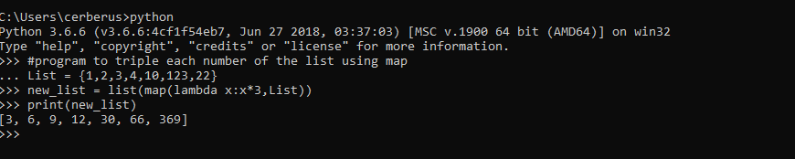

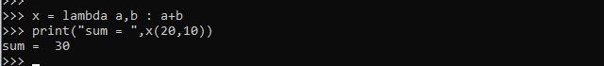

TOPIC2

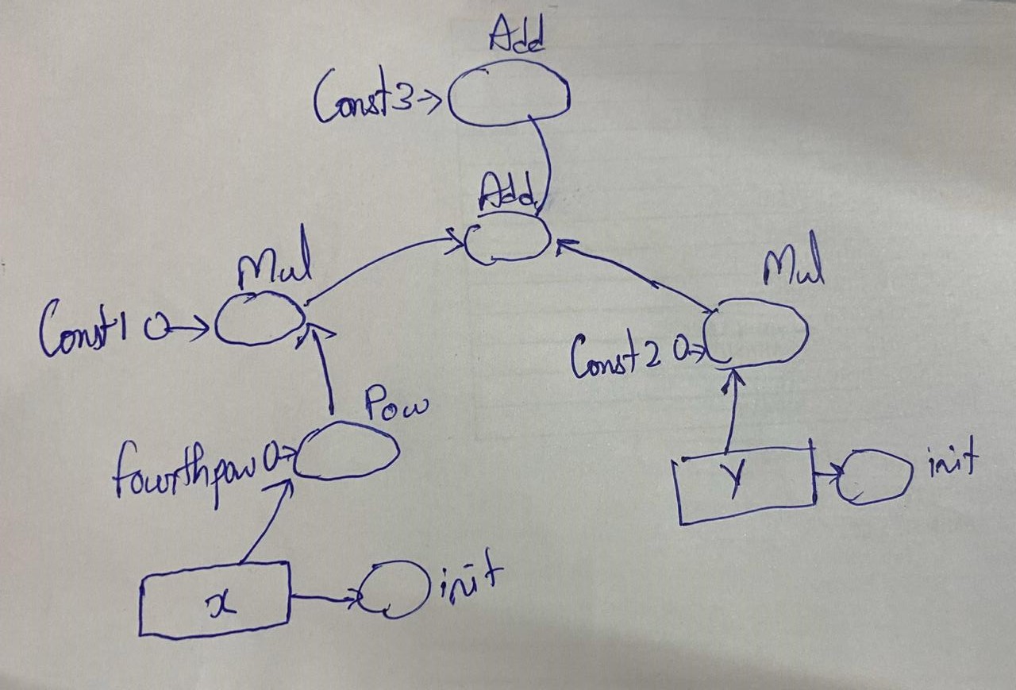

import tensorflow as tf

import numpy as np

data_placeholder_x = tf.placeholder(tf.int32, name = "data_placeholder_x")

data_placeholder_y = tf.placeholder(tf.int32, name = "data_placeholder_y")

const1 = tf.constant([2], name = "const1")

const2 = tf.constant([13], name = "const2")

const3 = tf.constant([1], name = "const3")

fourthpow = tf.constant([4], name = "fourthpow")

f = tf.multiply(const1,tf.pow(data_placeholder_x, fourthpow)) + tf.multiply(const2,data_placeholder_y) + const3

with tf.Session() as sess:

datax = [5]

datay = [6]

print(sess.run(f, feed_dict={data_placeholder_x: datax, data_placeholder_y: datay}))

*#output:-*

*#2020-03-05 04:13:59.763563: I tensorflow/core/platform/cpu_feature_guard.cc:142] Your CPU supports instructions that this TensorFlow binary was not compiled to use: AVX2*

*#[1329]*

TOPIC5

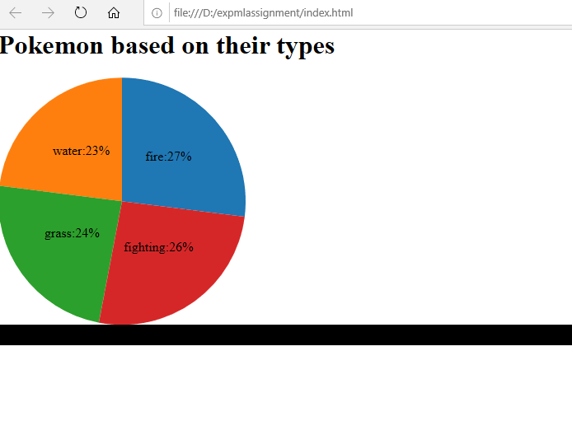

TOPIC6

